New Products Article (Mustard/Cocktail Sauce)
Draft One, 9-3-21/TT
Edits, 9-7-21/BY

Red Gold® Mustard and Seafood Cocktail Sauce Are Here!

Smart Additions from Red Gold Are Ready.

With nearly half of all restaurants offering mustard as a condiment* and a 27% jump in consumers buying seafood last year**, two new products from Red Gold are just in time to help your operation grow.

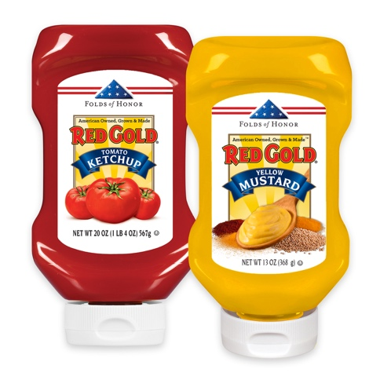
Red Gold’s new 13 oz. Yellow Mustard Squeeze Bottle joins Red Gold 20 oz. Ketchup for your tables.

Red Gold’s new 20 oz. Squeeze Bottle Yellow Mustard is the perfect match for operators already serving Red Gold Ketchup on their tables. A recent consumer survey by Datassential found that yellow mustard is a top five condiment favorite ahead of honey mustard and hot sauce. From burgers to sandwiches and hot dogs, the flavor is an absolute must.

This new one-two punch in flavor from Red Gold is matched by consumer interest in supporting the families of fallen U.S. military heroes. Proceeds from your purchase of either our new ketchup or mustard squeeze bottles goes to Folds of Honor. The charity provides educational scholarships to surviving family members for our fallen or disabled heroes. Since 2007, Folds of Honor has provided 29,000 scholarships. Visit RedGoldTomatoes.com/FoldsofHonor to learn more.

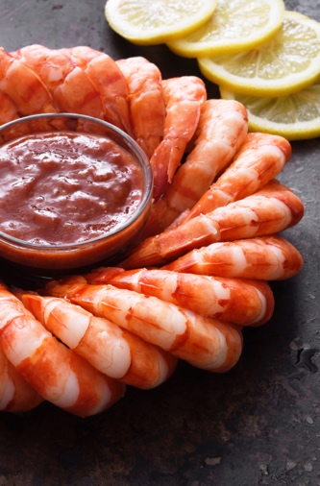
Try new Red Gold Seafood Cocktail Sauce.

Red Gold’s new Seafood Cocktail Sauce is available in convenient #10 cans as well as the new 64 oz. plastic pouch. Especially important for large volume seafood restaurants, this delicious cocktail sauce uses real horseradish for a rich and tangy flavor.

During the pandemic, consumers embraced seafood for its functional benefits. At home consumption of seafood was up 27% and there was a near 10% increase in the number of consumers saying that they now regularly eat seafood. This is a good time to add shrimp and other seafood items to your menu and don’t forget Red Gold’s new Seafood Cocktail Sauce!

Want to taste how good Red Gold’s new 13 oz. Squeeze Bottle of Yellow Mustard or pouch Seafood Cocktail Sauce really are? We’re happy to serve you with free samples. Order yours now.

*Datassential, 2021
**IRI, 2021

